2.44: a) Using a_{y} = –g, v_{0y} = 5.00 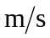 and y₀ = 40.0 m in Eqs. (2.8) and (2.12) gives
i) at t = 0.250 s,
y = (40.0 m) + (5.00 )(0.250 s) – (1/2)(9.80 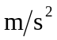)(0.250 s)² = 40.9 m,
v_{y} = (5.00 ) – (9.80 )(0.250 s) = 2.55

and ii) at t = 1.00 s,

y = (40.0 m) + (5.00 m/s)(1.00 s) – (1/2)(9.80 m/s²)(1.00 s)² = 40.1 m,
v_{y} = (5.00 ) – (9.80 )(1.00 s) = – 4.80 .

- Using the result derived in Example 2.8, the time is

t = 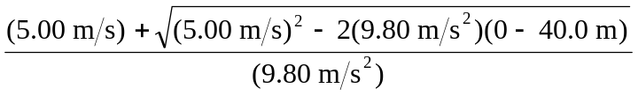= 3.41 s.

c) Either using the above time in Eq. (2.8) or avoiding the intermediate calculation by using Eq. (2.13),
v_{y} = 28.4.

d) Using v_{y} = 0 in Eq. (2.13) gives

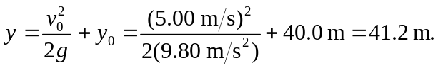

e)
